Recipe Manager Usage

This is a simple Recipe Manager program that allows you to view, update, add and delete recipes.

As noted in the diagram below there are 6 main functions.

1. This is the recipe list. This allows you to select recipes for viewing, updating, deleting and adding.
2. The add recipe function works in tandem with [5] where you can type the information of a recipe and press [2] to add the recipe to the list [1].
3. The update recipe function allows you to update a selected recipe, when a recipe is selected in the list [1] the information will populate in [5] and once you have made any relevant changes this can be saved by pressing [3].
4. Delete recipe works similar to update recipe, but rather than updating the recipe in the list [1] it will remove it.
5. This is the main recipe information dialogue, you will be presented with recipe information once a recipe is selected in the boxes with the relevant titles.
6. This button is for quitting the program.

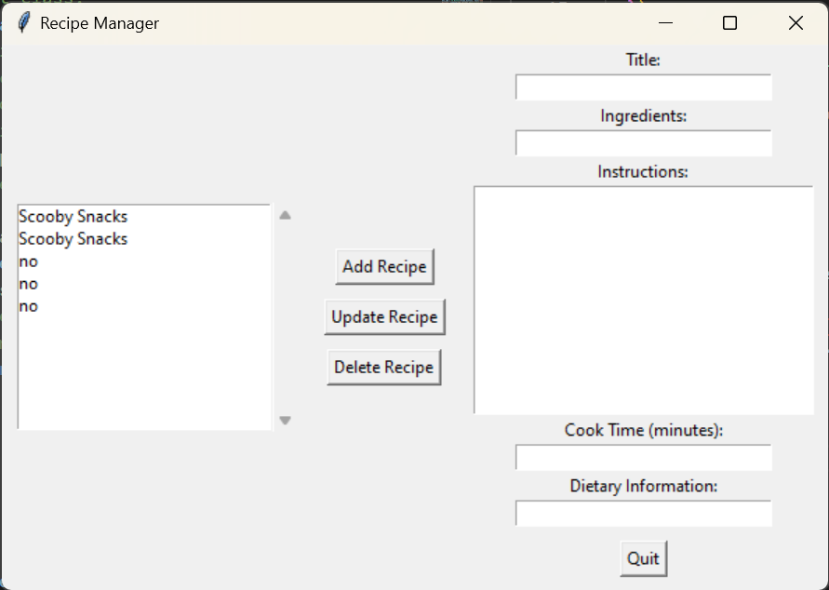

6

5

4

3

2

1

Do not worry if you do not have an existing recipe.txt file as the program will create this automatically for you.

Additionally, should you encounter problems with the recipe manager GUI there is also a CLI version of the program that allows you to make the same changes by simply running the program via terminal.

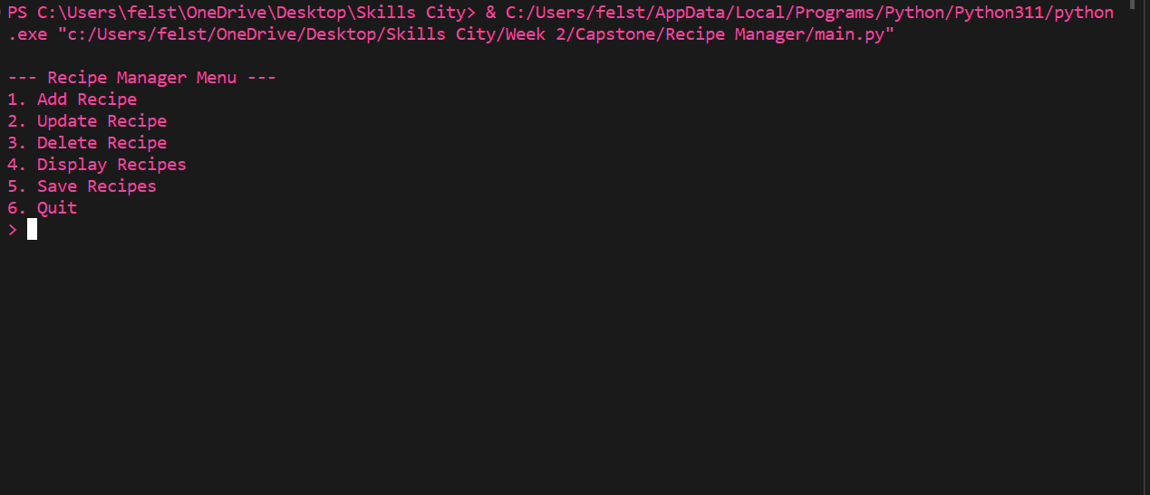

As you can see the functions are the same but require a numerical input. If you enter the number corresponding to the task you wish to enact, for example 4 to display recipes the CLI will then display all the recipes you have stored.

As this program is made in Python you will need Python to run it. It is also recommended you make a new folder for the Recipe Manager (or extract it as is from the .zip file) so that it creates or loads the recipes.txt in the right place.

Should you wish to review the code itself or modify the functions you will find that this is fully commented with clarification on what each part of the code is performing.

Thank you for choosing Team E’s Recipe Manager.